REPORT
Challenge to Change Poster Presentation
LAKSHYA 2026

1) Name of Event: Challenge to Change Poster Presentation
2) Date of Event : 18th April 2026, Saturday
3) Time: 9:30 am to 3:00 pm
4) Name of Expert: Shri Ashwin Vairu, Entrepreneur,
Shri Alpesh Pandya, Director, Aatman Corporation Ltd.
5) Name of Coordinator: Prof. Hiteshi Diwanji, Prof. Jyoti Iyer,
Prof. M. Y. Patil, Prof. Parth Raval,
Prof. Madhuri Patel, Prof. Keyur Hirpara,
Prof. Apexa Dharankar, Prof. Samruddhi Patel
6) Designation of Coordinator: Prof./Asst. Professor at LDCE
7) Email ID: psraval@gmail.com
8) Mobile No: 9925245668
9) Number of Participants: 140
10) Expert contact No. :
12) Expert email ID:
13) Expert’s Designation: Shri Ashwin Vairu, Entrepreneur,
Shri Alpesh Pandya, Director,
Aatman Corporation Ltd.

14) Photographs of Seminar:

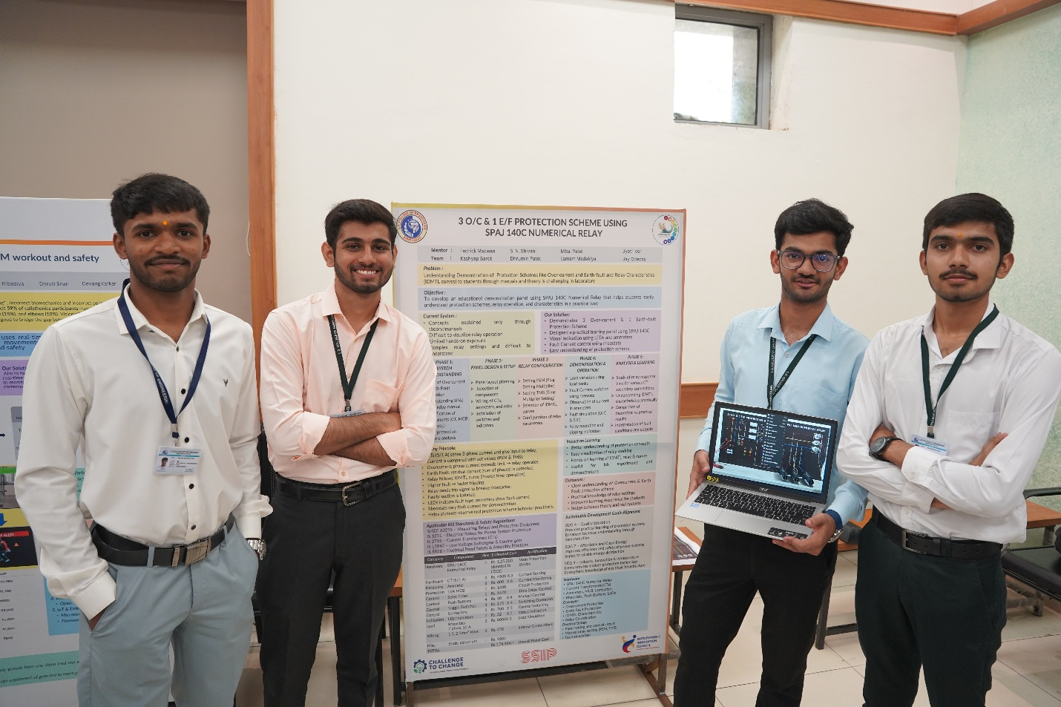
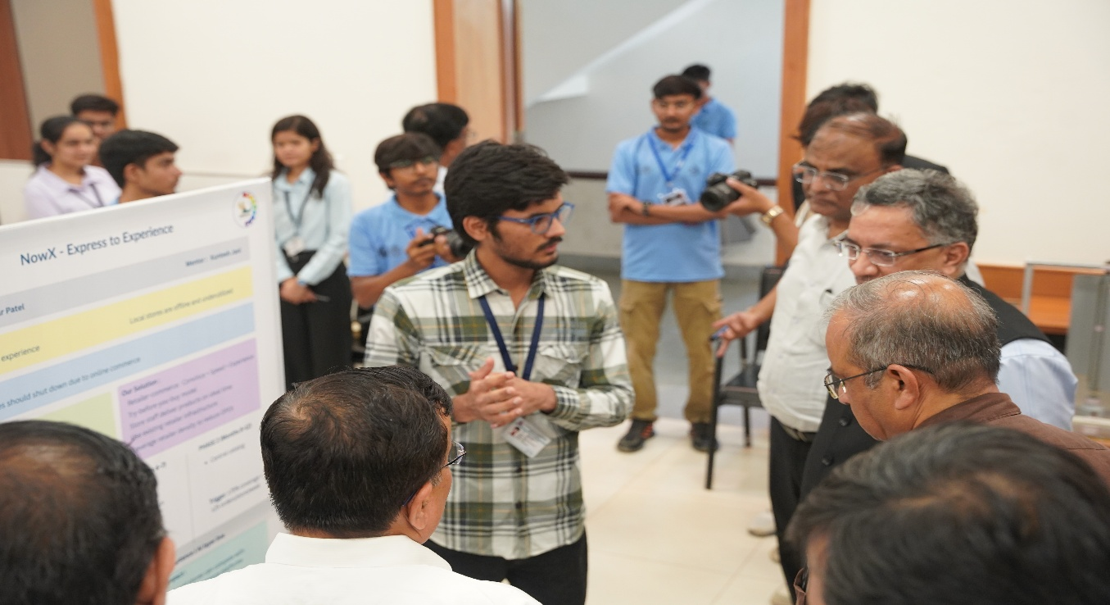

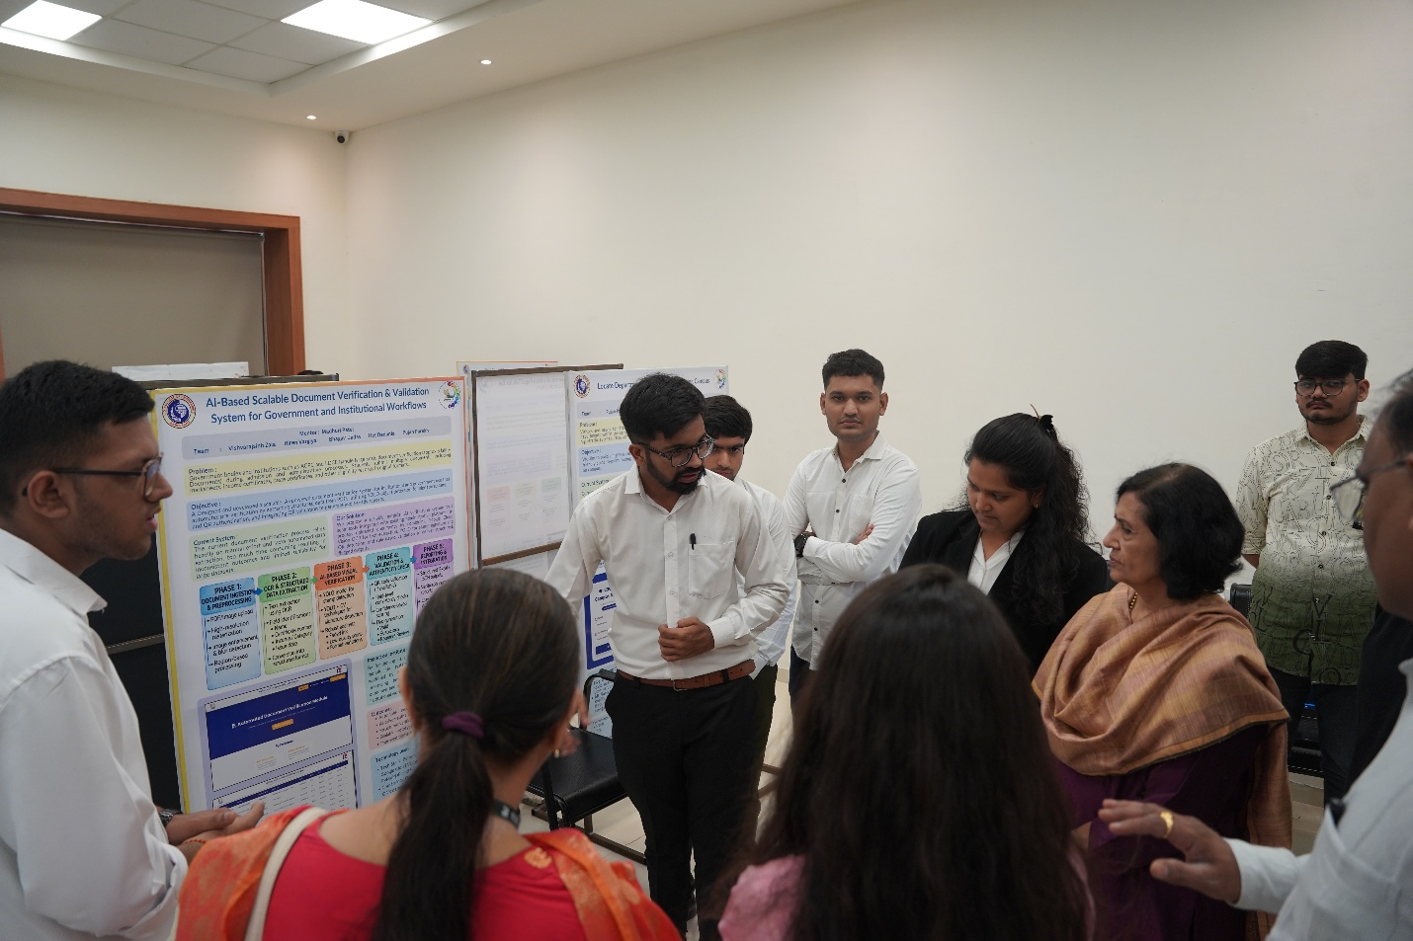

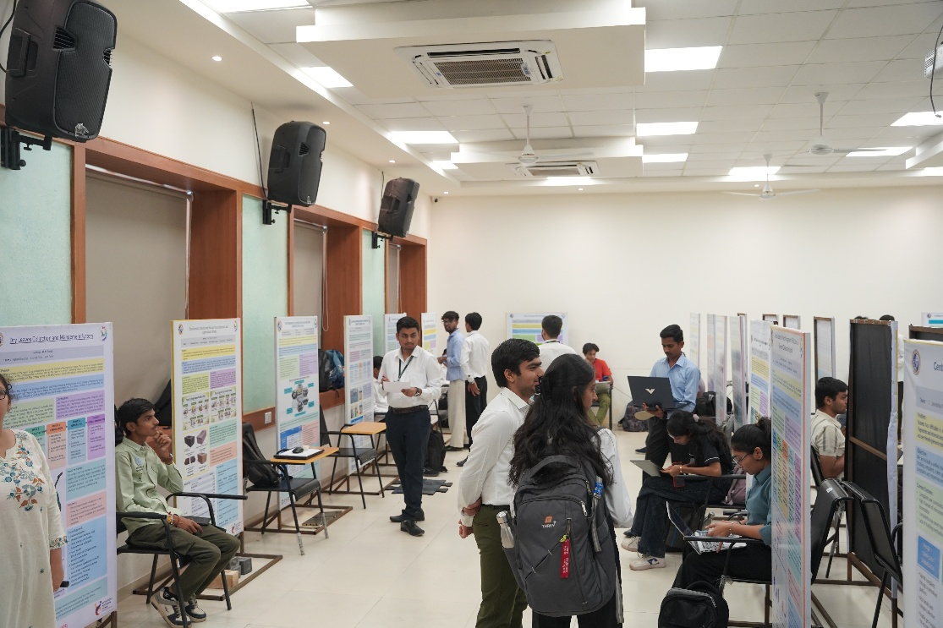
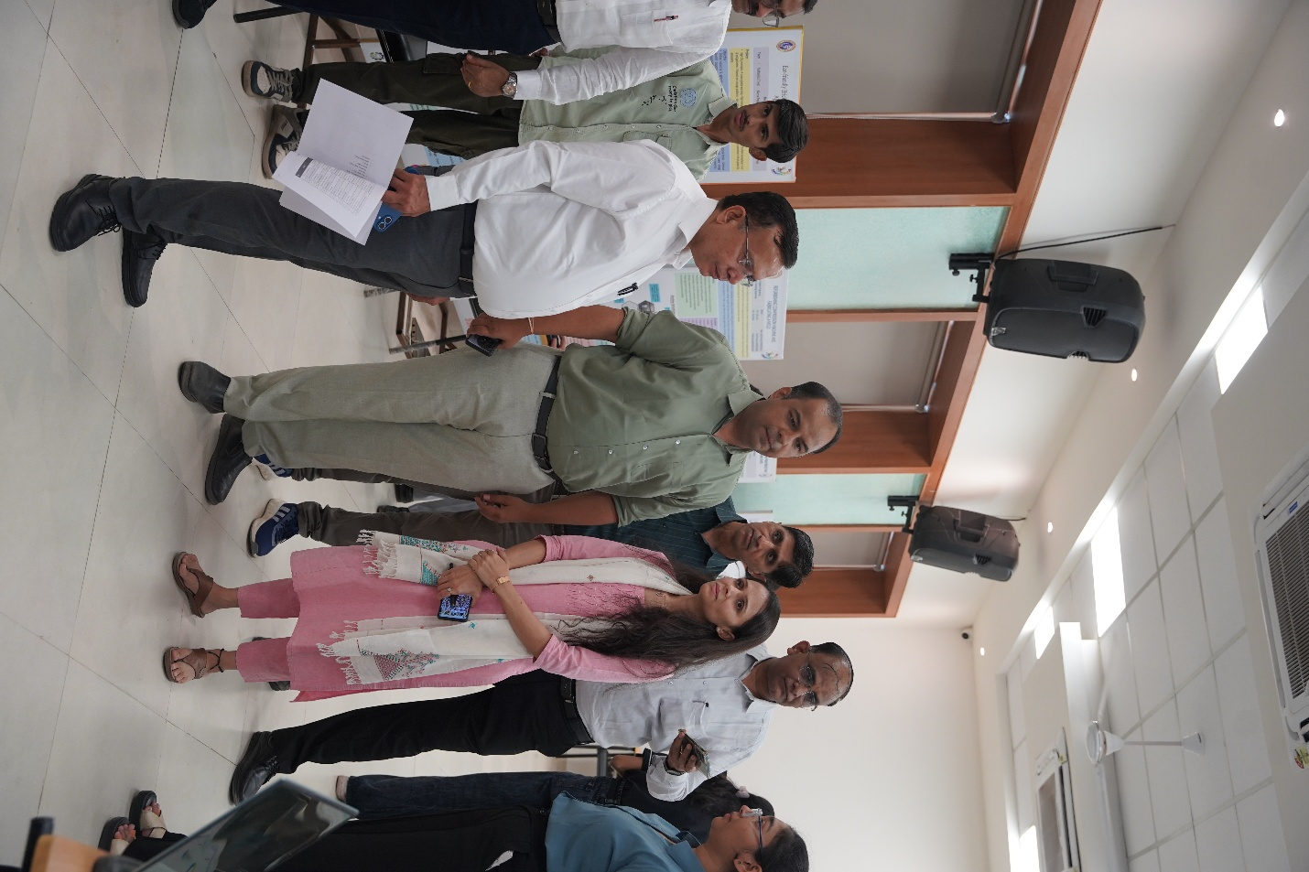

15) Venue: Dr. Homibhabha Hall, Bldg. No. 2, LDCE

About Event:
The C2C (Challenge to Change) Challenge is an initiative by the Technical Committee of L.D. College of Engineering that reflects a strong “by the students, for the students” approach, focusing on identifying real problems within the campus and developing practical, impactful solutions. Challenge to Change Poster Presentation is a dynamic technical conclave designed to bridge the journey from innovative concepts to real-world creation. The event brings together aspiring engineers to present ideas, showcase projects, and engage in insightful technical discussions that emphasize practical application and sustainable development. A wide range of projects were presented, including RFID-based library systems, AI-powered platforms, smart energy solutions, robotics, waste management innovations, and sustainability-driven technologies, demonstrating the institute’s commitment to innovation and applied learning.
The event was organized on 18th April 2026 as part of the Lakshya 2.0 celebration and was coordinated by Prof. Hiteshi Diwanji, Prof. Jyoti Iyer, Prof. M. Y. Patil, Prof. Parth Raval, Prof. Madhuri Patel, Prof. Keyur Hirpara,Prof. Apexa Dharankar and Prof. Samruddhi Patel. More than 30 final C2C projects that reached deployment stage were showcased, along with 11 additional projects from categories such as Design Engineering, SSIP, and postgraduate research, creating a diverse and multidisciplinary technical platform. Students from various departments actively participated, presenting posters on academic, technological, environmental, and social themes, explaining their work to judges and guests, with evaluation based on creativity, content quality, presentation skills, and subject understanding. The event was honoured by the presence of distinguished dignitaries including
- Shri Mukesh Kumar, IAS, Additional Chief Secretary, Higher and Technical Education
- Shri Bipin Talati, IAS, Commissioner of Technical Education Department
- Dr. Rajul K. Gajjar, Vice Chancellor, Gujarat Technological University (GTU)
- Dr. M. N. Patel, Ex. Principle of LDCE
- Dr. V. V. Prajapati, Joint Director, CTE
- Dr. K. V. Modi, Joint Director, CTE
- Shri P. B. Shah, Deputy Director, CTE
- Shri Prerak Shah, Joint MD, DevIT Ltd.
- Shri Kuntal Sanghvi, President, Government Business, Adani University
- Shri Umesh Nayak, President, Government Business, AM and NS
- Shri Sanjay Sharma, MD , Sabarmati Gas Ltd
- Dr. S. R. Joshi, Principle, GEC- Surat
- Dr. S. N. Pandya, HOD Electrical, VGEC
The Poster Presentation Event was successfully conducted with active student participation and valuable guidance from invited guests. Winners were awarded certificates in recognition of their outstanding work. The event effectively showcased innovative ideas and their transformation into practical solutions, reinforcing a strong culture of research, collaboration, and application-oriented learning at L.D. College of Engineering.
Rank | Project Title | Track Category | Student Name(s) | Mentor Name
1 | Fake Document Detection and Automation and Validation of Student Admission Documents | Software Implementation | Vishvarajsinh K. Zala, Het Dedania,  Hiren Vargiya,  Bhargav Jadav,  Pujan Parekh | Prof. Madhuri Patel,  Prof. Keyur Hirpara,  Prof. S. J. Padhiyar,  Prof. Parth Raval
2 | AI-Powered Chatbot for LDCE Website to Enhance User Interaction and Information Accessibility | Software Implementation | Bhavya Fattania,  Pruthil Prapapati,  Arvind Chaudhary | Dr. Maitrik Shah,  Prof. Pragnesh Patel
3 | Unified Academic Monitoring & NBA Reporting System | Software Implementation | Hiren Vargiya,  Souvik Hazra,  Viraj Rathod,  Bhumika Vasan,  Mercy Vasant,  Het Virani | Dr. Apexa Dharankar
1 | Design and Development of a RFID System for the Library | Hardware Implementation | Jasmin Maheriya,  Dhruvi Rana,  Naveena Sanjay,  Jitu Kumarkhaniya, Krish Aagaja | Prof. S. S. Pathan
2 | 6 DOF Manipulator Arm | Hardware Implementation | Bhavin Prajapati,  Arman Amreliya,  Aman Amreliya,  Fatima Shaikh,  Krishna Kalsariya | Prof. M. Y. Patil
3 | Eco-Friendly Interlocking Rubber Paver Block from Waste Tyre Rubber | Hardware Implementation | Machhi Rohan Chandubhai,  Vadadoriya Dhruvi Hareshbhai,  Prajapati Dev Ghanshyambhai | Prof. Sunil Padhiyar
1 | Lightweight Arrhythmia Detection and Prediction using Deep Learning on Edge Devices | ME / SSIP / Design Engineering | Djika Djibrila Abdou Bontianti | Dr. Shital Solanki,  Prof. Jaimin Chavda
2 | Fault Analyzer and Logic Controller | ME / SSIP / Design Engineering | Susmita Mallick,  Izhan Mansuri, Kashish Tanna,  Sujan Juneja, Rudra Bhatt | Fedrik Macwan

